Add new identity

Flow diagram

1.1 Validate and add new identity

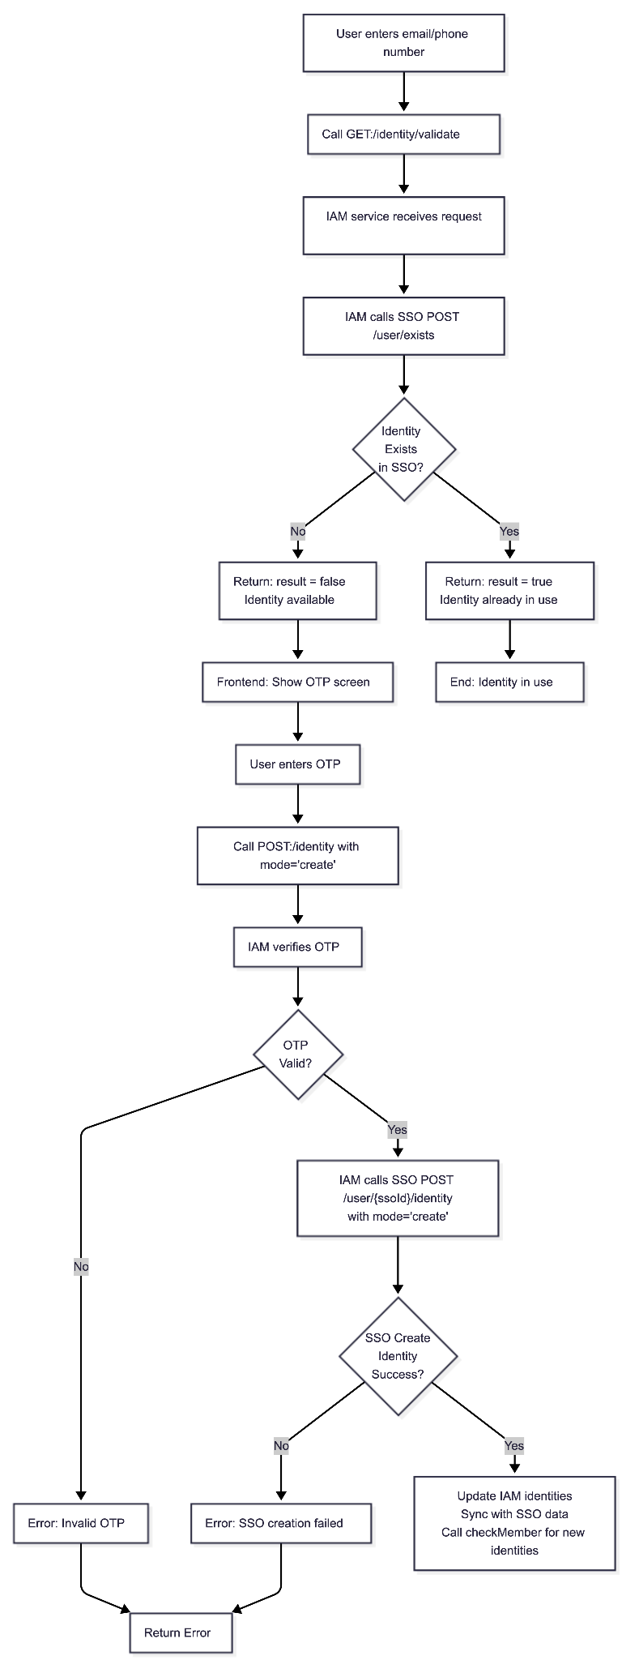

1.2 Checking and sync workplace member
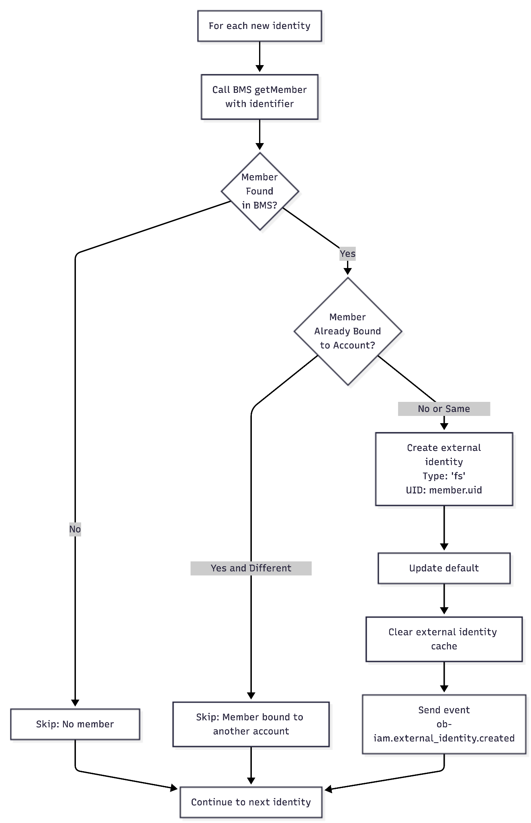

Preview Screen
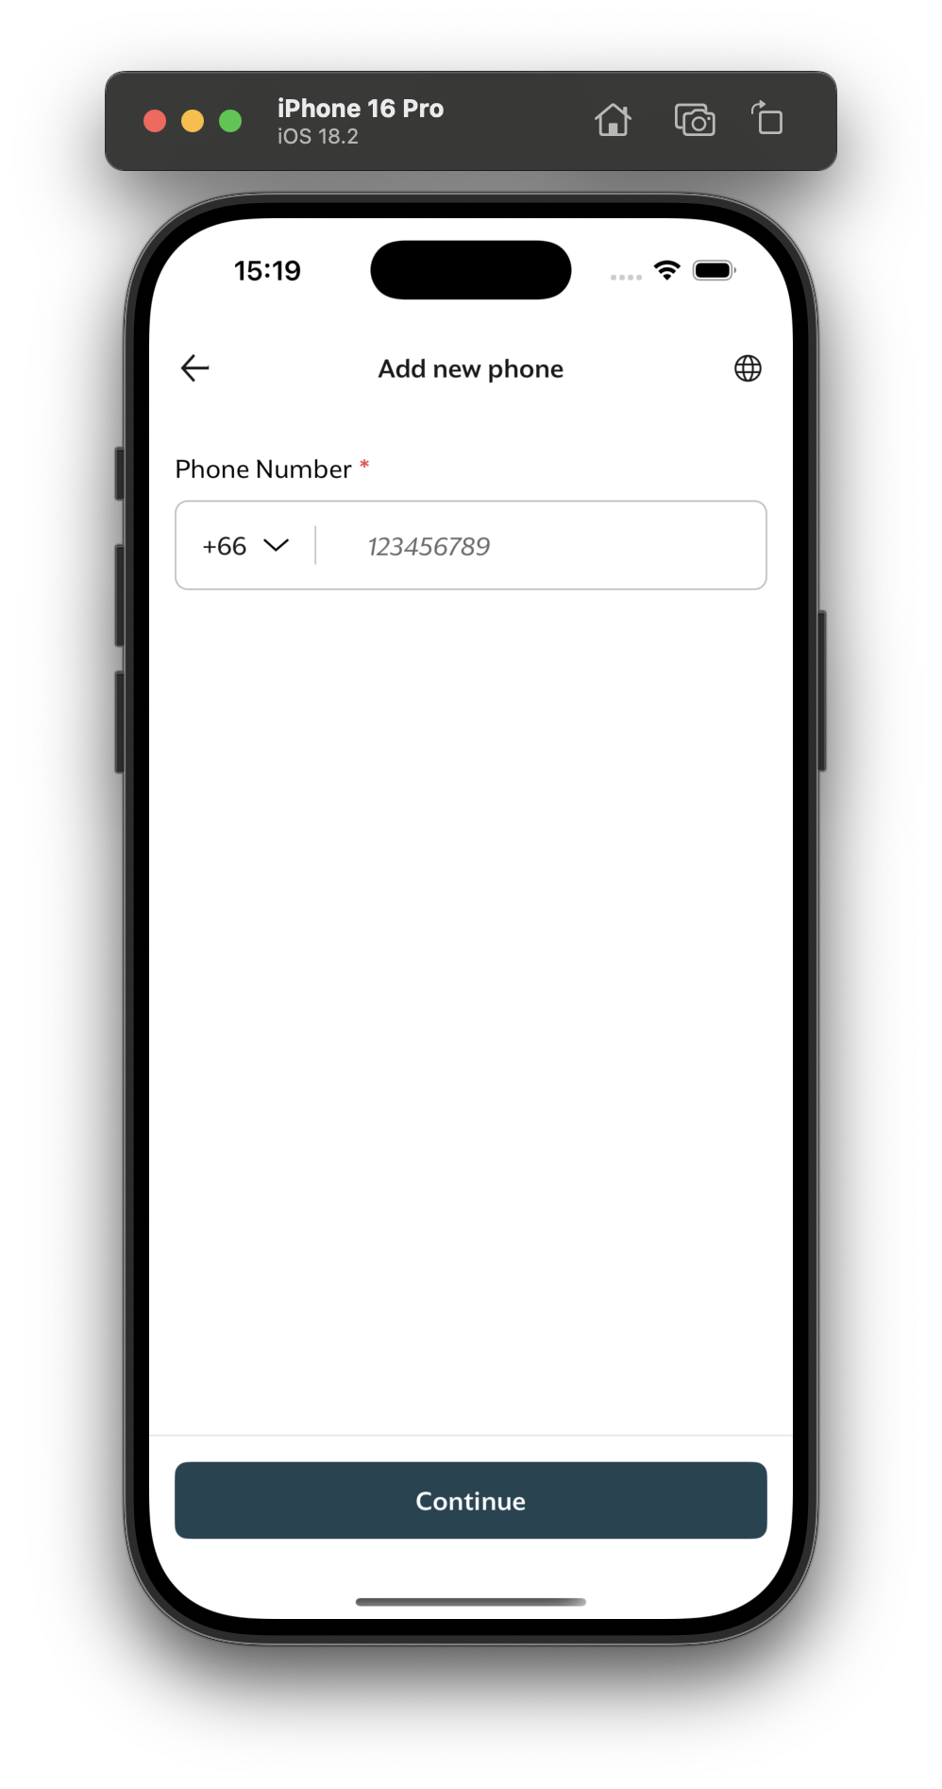

Sequence diagram

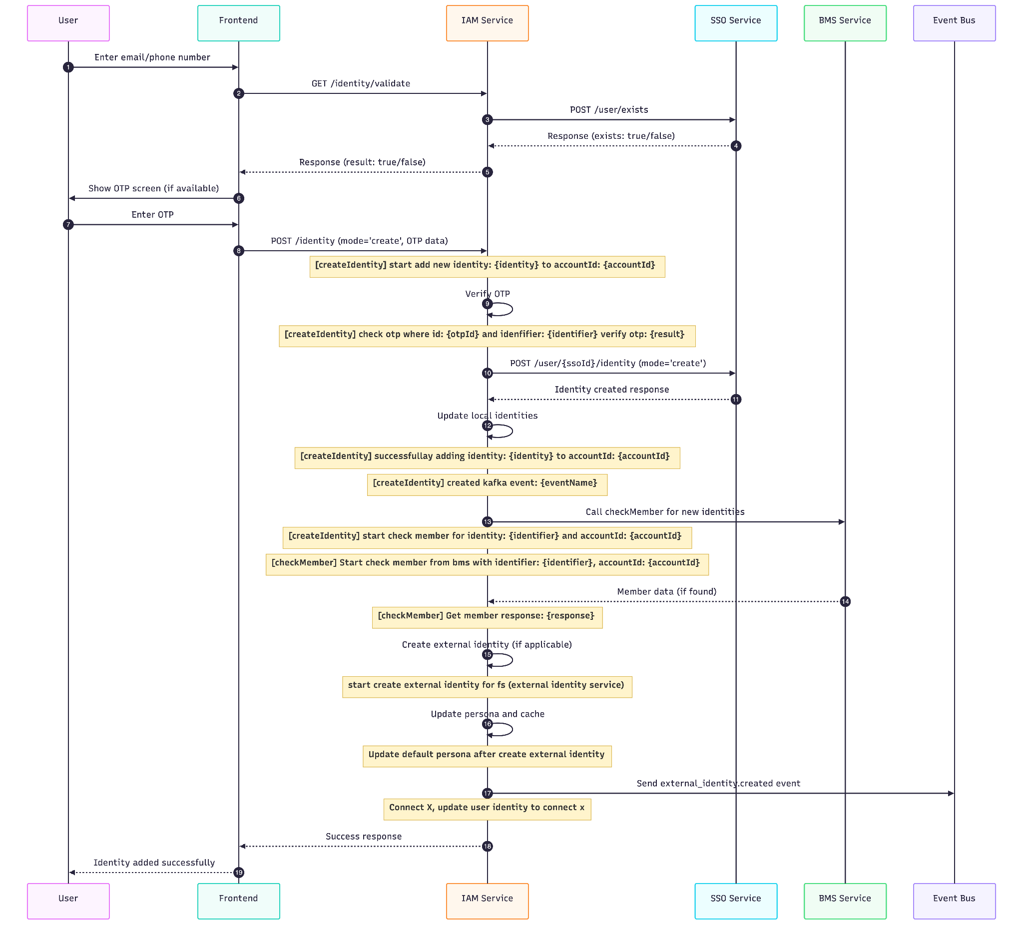

API description

3.1 Validate identity

Description
Validates if an identity (email/phone) is available for use

Example Request - IAM
GET /identity/validate?provider=email&identifier=user%40example.com
app-version: 2.0.0

Request Parameters - IAM
Name | Type | Required | Description
provider | string | Yes | Identity provider type (email, phone, sso)
identifier | string | Yes | Email address or phone number to validate
country_code | string | No | Country dialing code for phone numbers, e.g. +1
scope | string | No | Optional scope filter for validation
filter | string | No | Optional filter for identity checking

Example Response - IAM
{
"data": {
"result": false
}
}

Response detail
Result | Description
true | No identity found in system user can you this identity to create
false | Identity already exist in the system

Error Scenarios
Error Code | HTTP Status | Description | Cause | Resolution
OB_007 | 400 | Invalid provider | Unsupported or missing provider | Use a valid provider from the supported list
OB_007 | 400 | Invalid identifier | Malformed or empty identifier | Provide a valid identifier for the provider
OB_001 | 500 | SSO service error | Issue with SSO client communication | Check SSO service status and logs

Example Error Responses

400 Bad Request - Invalid Provider
{
"error": {
"code": "OB_007",
"message": "invalid parameters, provider is required",
"stack": "Error: invalid parameters, provider is required\n at identityValidateHandler ..."
}
}

400 Bad Request - Invalid Identifier
{
"error": {
"code": "OB_007",
"message": "invalid parameters, identifier is required",
"stack": "Error: invalid parameters, identifier is required\n at identityValidateHandler ..."
}
}

500 Internal Server Error - SSO Service Error
{
"error": {
"code": "OB_001",
"message": "internal server error",
"stack": "Error: Failed to communicate with SSO service\n at SSOClient.checkExistingIdentity ..."
}
}

Example request - SSO
POST /user/exists
Content-Type: application/json
clientId: 1234
clientSecret: 1234
{
"email": "user@example.com"
}

Request Headers - SSO
Header | Type | Required | Description
clientId | string | Yes | Client identification key
clientSecret | string | Yes | Client secret for authentication

Request Body - SSO
Rule: One of email, phoneNumber, or uid must be provided
Field | Type | Required | Description
email | string | No | Email address to check
phoneNumber | string | No | Phone number to check
uid | string | No | UID to check
scope | array | No | Scope to check (defaults to ["sso", "iam", "bzb"])
filter | string | No | Filter for checking (e.g., "bzb-unmerged")

Example response - SSO
{
"isFound": false,
"isSuspended": false
}

Response detail
Result | Description
isFound | true if identity exist in the system  false if identity not exist in the system
isSuspended | Existing identity is associated with a suspended account.

Error Scenarios - SSO
HTTP Status | Description | Cause
400 | Bad Request | No identity provided or more than one identity field included
401 | Unauthorized | Invalid client authentication credentials

Example Error Response

400 Bad Request Error
{
"error": {
"code": "OB_0010",
"message": "One of email, phone number, or UID must be provided",
"stack": "Error: One of email, phone number, or UID must be provided\n at ..."
}
}

3.2 Add new identity

Description
Adds a new identity to an existing account after OTP verification

Example request - IAM
POST /identity
Content-Type: application/json
X-account-id: abc-1234
app-version: 2.0.0
{
"identity": {
"provider": "email",
"identifier": "user@example.com"
},
"otp": {
"id": "otp-id-1234"
},
"mode": "create"
}

Example response - IAM
{
"data": {
"result": true
}
}

Error Scenarios - IAM
Error Code | HTTP Status | Description | Cause | Resolution
IAM_OTP_003 | 400 | Invalid OTP | OTP verification failed | Request new OTP and try again
IAM_IDT_0013 | 500 | SSO creation failed | Failed to create identity in SSO | Check SSO service status
IAM_SSO_007 | 400 | Missing SSO identity | Account missing SSO external ID | Ensure account has SSO linkage

Example Error Responses

400 Bad Request Error
{
"error": {
"code": "IAM_OTP_003",
"message": "invalid otp",
"stack": "Error: invalid otp\n at ..."
}
}

500 Internal Server Error
{
"error": {
"code": "IAM_IDT_0013",
"message": "SSO creation failed",
"stack": "Error: SSO creation failed\n at ..."
}
}

400 Bad Request Error (Missing SSO Identity)
{
"error": {
"code": "IAM_SSO_007",
"message": "missing SSO identity",
"stack": "Error: missing SSO identity\n at ..."
}
}

Example request - SSO
POST /user/sso_1234567890/identity
Content-Type: application/json
clientId: 1234
clientSecret: 1234
{
"identifier": "user@example.com",
"provider": "email",
"mode": "create"
}

Authentication
Header | Type | Required | Description
clientId | string | Yes | Client identification key
clientSecret | string | Yes | Client secret for authentication

Path Parameter
Name | Type | Required | Description
id | string | Yes | The public SSO user ID (for example, sso_xxxx)

Request Body
Field | Type | Required | Description
identifier | string | Yes | The identity value to add
provider | string | Yes | Identity provider: "email", "phone", "sso", "keycloak"
mode | string | No | Mode: "create", "merge" (defaults to "create")

Example response - SSO
{
"id": "00000000-0000-0000-0000-000000000000",
"publicId": "sso_1234567890",
"createdAt": "2026-01-01T00:00:00.000Z",
"updatedAt": "2026-01-02T00:00:00.000Z",
"status": "active",
"registrationType": "thai",
"suspendedAt": null,
"identites": [
{
"id": "11111111-1111-1111-1111-111111111111",
"provider": "email",
"identifier": "user@example.com",
"default": false,
"meta": null,
"createdAt": "2026-01-02T00:00:00.000Z",
"updatedAt": "2026-01-02T00:00:00.000Z",
"accountId": "00000000-0000-0000-0000-000000000000"
}
],
"externalIdentities": [],
"migrationCampaignRedeem": {}
}

Error Scenarios
HTTP Status | Description | Cause
404 | Not Found | Public SSO ID does not resolve to an account
401 | Unauthorized | Invalid client authentication credentials
400 | Bad Request | Request body is malformed

Example Error Response

404 Not Found
{
"status": 404,
"error": {
"code": "SSO_ACC_002",
"message": "SSO ID not found",
"stack": "Error: SSO ID not found\n at ..."
}
}

Cache Keys
Key | TTL | Purpose
EXTERNAL_IDENTITY_CACHE_KEY_KEY_{accountId} | 3600 seconds | Stores the list of external identity cache keys for an account so they can be invalidated together.
EXTERNAL_IDENTITY_CACHE_KEY_account_id_{accountId} | 3600 seconds | Cached external identities by account ID. Deleted when external identity data changes.
EXTERNAL_IDENTITY_CACHE_KEY_identifier_{identifier} | 3600 seconds | Cached external identities by identifier. Deleted through the account key registry.
EXTERNAL_IDENTITY_CACHE_KEY_uid_{uid} | 3600 seconds | Cached external identities by external UID. Deleted through the account key registry.
CACHE_PROFILE_{accountId} | 7200 seconds | Cached IAM profile payload. Deleted when a new external identity changes persona/profile resolution.
CNX_ACCESS_TOKEN | 3540 seconds | Cached Connect X access token used by Connect X registration/update calls.

